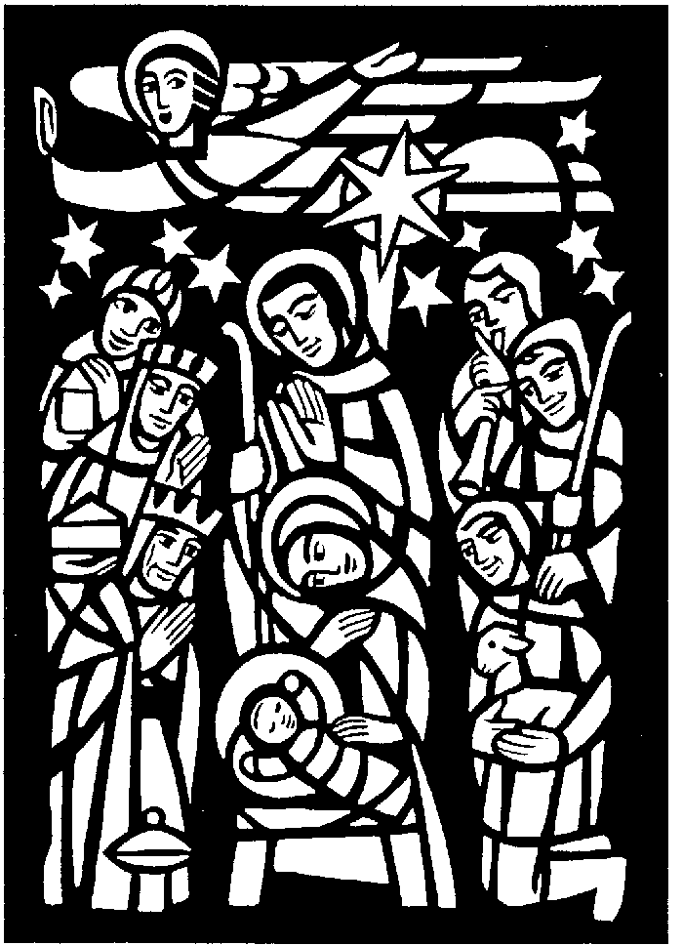

The Parish Church of

Saint Andrew

Orford with Longford

**Midnight Mass**

**of the Nativity**

**2018**

Entrance Hymn: 62 "O come all ye faithful" verses 1, 2 and 3

**THE BLESSING OF THE CRIB**

Priest: Grace, mercy and peace from God our Father and the Lord Jesus Christ be with you

All: and also with you.

Priest: Dear friends, as we meet to celebrate the birth of Christ, let us pray that God will bless this crib, that all who worship his Son, born of the Virgin Mary, may come to share his life in glory:

God our Father, on this night your Son Jesus Christ was born of the Virgin Mary for us and for our salvation: ✠ bless this crib which we have prepared to celebrate that holy birth; may all who see it be strengthened in faith, and receive the fullness of life he came to bring; who is alive and reigns for ever.

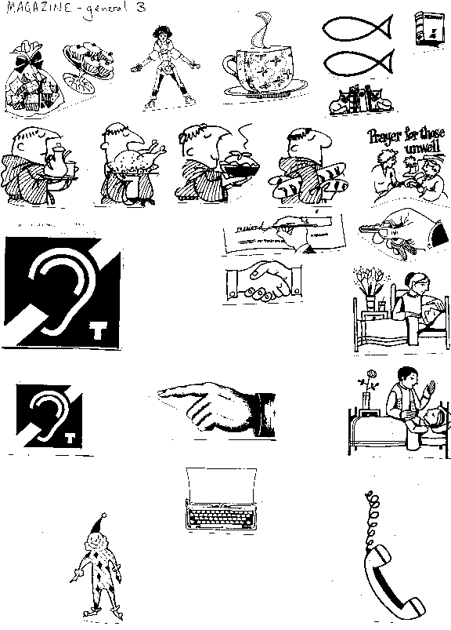All: Amen

Hymn: 62 "O come all ye faithful" verses 6 and 7

**PRAYERS FOR PURITY**

Priest: Christ the light of the world has come to dispel the darkness of our hearts. In his light, let us examine ourselves and confess our sins.

*After a period of silent reflection:*

Priest: God our Father, you sent your Son full of grace and truth: forgive our failure to receive him. Lord have mercy.

All: Lord have mercy.

Priest: Jesus our Saviour, you were born in poverty and laid in a manger: forgive our greed and rejection of your ways. Christ have mercy.

All: Christ have mercy.

Priest: Spirit of love, your servant Mary responded joyfully to your call: forgive the hardness of our hearts. Lord have mercy.

All: Lord have mercy.

Priest: May the God of all healing and forgiveness draw you to himself, that you may behold the glory of his Son, the Word made flesh, and be cleansed from all your sins, through Jesus Christ our Lord. **Amen.**

All 🎜 Glory to God in the highest, and peace to his people on earth. Lord God, heavenly King, almighty God and Father, we worship you, we give you thanks, we praise you for your glory. Lord Jesus Christ, only Son of the Father, Lord God, Lamb of God, you take away the sin of the world: have mercy on us; you are seated at the right hand of the Father: receive our prayer. For you alone are the Holy One, you alone are the Lord, you alone are the Most High, Jesus Christ, with the Holy Spirit, in the glory of God the Father. Amen.

**The Collect:** Eternal God, who made this most holy night to shine with the brightness of your one true light: bring us, who have known the revelation of that light on earth, to see the radiance of your heavenly glory; through Jesus Christ your Son our Lord, who is alive and reigns with you, in the unity of the Holy Spirit, one God, now and for ever. **Amen.**

#### THE LITURGY OF THE WORD

**A reading from the book of the prophet Isaiah** *(Isa. 52.7–10)*

How beautiful upon the mountains are the feet of the messenger who announces peace, who brings good news, who announces salvation, who says to Zion, ‘Your God reigns.’ Listen! Your sentinels lift up their voices, together they sing for joy; for in plain sight they see the return of the Lord to Zion. Break forth together into singing, you ruins of Jerusalem; for the Lord has comforted his people, he has redeemed Jerusalem. The Lord has bared his holy arm before the eyes of all the nations; and all the ends of the earth shall see the salvation of our God.

This is the word of the Lord.

All: Thanks be to God.

**Hymn** *(please remain seated)***:** 55 ‘In the bleak midwinter’

**A reading from the letter to the Hebrews**  *(Heb. 1. 1-4)*

Long ago God spoke to our ancestors in many and various ways by the prophets, but in these last days he has spoken to us by a Son, whom he appointed heir of all things, through whom he also created the worlds. He is the reflection of God’s glory and the exact imprint of God’s very being, and he sustains all things by his powerful word. When he had made purification for sins, he sat down at the right hand of the Majesty on high, having become as much superior to angels as the name he has inherited is more excellent than theirs.

This is the word of the Lord.

All: Thanks be to God.

**Gradual Hymn:** 76 ‘While shepherds watched their flock by night’

**THE GOSPEL:** *[please remain standing]*

Priest: The Word became flesh and dwelt among us, and we have seen his glory.

All 🎜 Alleluia, alleluia, alleluia, alleluia; alleluia, alleluia, alleluia.

Priest: Hear the Gospel of our Lord Jesus Christ according to John  *(Jn1.1-14)*

All 🎜 Glory to you, O Lord

In the beginning was the Word, and the Word was with God, and the Word was God. He was in the beginning with God. All things came into being through him, and without him not one thing came into being. What has come into being in him was life, and the life was the light of all people. The light shines in the darkness, and the darkness did not overcome it. There was a man sent from God, whose name was John. He came as a witness to testify to the light, so that all might believe through him. He himself was not the light, but he came to testify to the light. The true light, which enlightens everyone, was coming into the world. He was in the world, and the world came into being through him; yet the world did not know him. He came to what was his own, and his own people did not accept him. But to all who received him, who believed in his name, he gave power to become children of God, who were born, not of blood or of the will of the flesh or of the will of man but of God. And the Word became flesh and lived among us, and we have seen his glory, the glory as of a father’s only son, full of grace and truth.

This is the Gospel of the Lord

All 🎜 Praise to you, O Christ.

**The Sermon**

All stand to say the Nicene Creed:

Priest: We believe in one God,

**All: the Father, the almighty, maker of heaven and earth, of all that is, seen and unseen.**

We believe in one Lord, Jesus Christ, the only Son of God, eternally begotten of the Father, God from God, Light from Light, true God from true God, begotten, not made, of one Being with the Father; through him all things were made. For us and for our salvation he came down from heaven, was incarnate from the Holy Spirit and the Virgin Mary and was made man. For our sake he was crucified under Pontius Pilate; he suffered death and was buried.

On the third day he rose again in accordance with the Scriptures; he ascended into heaven and is seated at the right hand of the Father. He will come again in glory to judge the living and the dead, and his kingdom will have no end.

We believe in the Holy Spirit, the Lord, the giver of life, who proceeds from the Father and the Son, who with the Father and the Son is worshipped and glorified, who has spoken through the prophets. We believe in one holy catholic and apostolic Church. We acknowledge one baptism for the forgiveness of sins. We look for the resurrection of the dead, and the life of the world to come. Amen.

THE INTERCESSION

Priest: In peace let us pray to the Lord

*Each section ends:* Holy God [**All:] hear our prayer.**

THE LITURGY OF THE SACRAMENT

**The Peace**   *(please stand)*

Priest: This holy night the angels sang, ‘Glory to God in the highest heaven, and on earth peace to all in whom he delights.’

The peace of the Lord be always with you

All: and also with you

Priest: Let us offer one another a sign of peace.

Everyone is invited to exchange a sign of peace with one another.

**Offertory Hymn**  56 "It came upon a midnight clear"

During the singing of the hymn, a collection is taken, and bread and wine are brought to the altar. The collection is for work with the **homeless here in Warrington.**

EUCHARISTIC PRAYER E *(please kneel)*

Priest:The Lord is here.

All 🎜 His Spirit is with us.

Priest:Lift up your hearts.

All 🎜 We lift them to the Lord.

Priest:Let us give thanks to the Lord our God.

All 🎜 It is right to give thanks and praise.

Priest:All glory and honour be yours always and everywhere, mighty creator, ever-living God. We give you thanks and praise for your Son, our Saviour Jesus Christ, who for love of our fallen race humbled himself, and on this night was born of the Virgin Mary by the power of your Spirit, and lived as one of us. In this mystery of the Word made flesh you have caused his light to shine in our hearts, to give knowledge of your glory in the face of Jesus Christ. In him we see our God made visible and so are caught up in the love of the God we cannot see. Therefore with all the angels of heaven we lift our voices to proclaim the glory of your name and sing our joyful hymn of praise:

All 🎜 Holy, holy, holy Lord, God of power and might, heaven and earth are

full of your glory. Hosanna in the highest. Blessed is he who comes in the name of the Lord. Hosanna in the highest.

Priest:We praise and bless you, loving Father, through Jesus Christ, our Lord; and as we obey his command, send your Holy Spirit, that broken bread and wine outpoured may be for us the body and blood of your dear Son.

On the night before he died he had supper with his friends and, taking bread, he praised you. He broke the bread, gave it to them and said: Take, eat; this is my body which is given for you; do this in remembrance of me.

When supper was ended he took the cup of wine. Again he praised you, gave it to them and said: Drink this, all of you; this is my blood of the new covenant, which is shed for you and for many for the forgiveness of sins. Do this, as often as you drink it, in remembrance of me.

So, Father, we remember all that Jesus did, in him we plead with confidence his sacrifice made once for all upon the cross. Bringing before you the bread of life and cup of salvation, we proclaim his death and resurrection until he comes in glory.

Great is the mystery of faith:

All 🎜 Christ has died: Christ is risen: Christ will come again.

Lord of all life, help us to work together for that day when your kingdom comes and justice and mercy will be seen in all the earth. Look with favour on your people, gather us in your loving arms and bring us with all the saints to feast at your table in heaven. Through Christ, and with Christ, and in Christ, in the unity of the Holy Spirit, all honour and glory are yours, O loving Father, for ever and ever. **Amen.**

Priest: Rejoicing in the presence of God here among us, let us pray with confidence as our Saviour has taught us:

All: Our Father, who art in heaven, hallowed be thy name; thy kingdom come; thy will be done; on earth as it is in heaven. Give us this day our daily bread. And forgive us our trespasses, as we forgive those who trespass against us. And lead us not into temptation; but deliver us from evil. For thine is the kingdom, the power and the glory, for ever and ever. Amen.

Priest: We break the bread of life, and that life is the light of the world.

**All: God is here among us, light in the midst of us,**

**bring us to light and life**

All 🎜 Lamb of God, you take away the sin of the world, have mercy on us.

Lamb of God, you take away the sin of the world, have mercy on us.

Lamb of God, you take away the sin of the world, grant us peace.

Priest: Jesus is the Lamb of God who takes away the sin of the world.

Blessed are those who are called to his supper.

**All: Lord, I am not worthy to receive you,**

**but only say the word, and I shall be healed.**

Holy Communion is administered at the front of Church - please follow the directions of the wardens. Everyone is warmly invited to receive Holy Communion at this Eucharist. Those who prefer to receive a blessing are also invited to come forward at the same time.

During the distribution of the Sacrament, the following will be sung:

**Hymn**  69 (version 2) ‘Silent Night’

63 ‘O little town of Bethlehem’

**After Communion**

Priest: Let us pray:

God our Father, in this night you have made known to us again the coming of our Lord Jesus Christ; confirm our faith and fix our eyes on him until the day dawns and Christ the Morning Star rises in our hearts.

All: To him be glory both now and for ever. Amen.

All: Father of all, we give you thanks and praise, that when we were still far off you met us in your Son and brought us home. Dying and living, he declared you love, gave us grace, and opened the gate of glory. May we who share Christ’s body live his risen life; we who drink his cup bring life to others; we whom the Spirit lights give light to the world. Keep us firm in the hope that you have set before us, so we and all your children shall be free, and the whole earth live to praise your name; through Jesus Christ our Lord. Amen.

Priest: Christ, who by his incarnation gathered into one all things earthly and heavenly, fill you with his joy and peace; and the blessing of God almighty, the Father, the Son and the Holy Spirit, be among you, and remain with you always. **Amen.**

**Recessional Hymn:** 53 "Hark the herald angels sing"

Priest: Go in peace. Proclaim the Word made flesh.

All: Glory, thanks and praise to God.

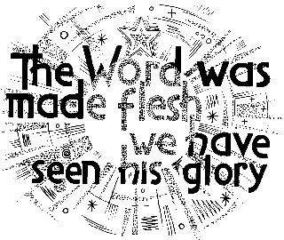

Services for the week:

**Christmas morning:**

**10.00am Family Communion with Carols**

**Wednesday 26th: St Stephen, the First Martyr**

**7.00pm Sung Eucharist**

**Thursday 27th St John the Evangelist**

**10.30am Eucharist**

**Friday 28th The Holy Innocents**

**10.30am Sung Eucharist**

**Next Sunday The First Sunday of Christmas**

**(30th Dec) 10.00am Sung Eucharist**

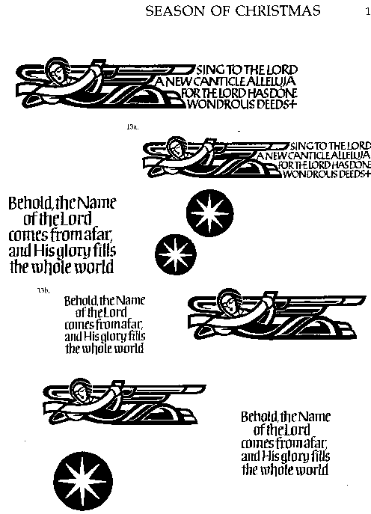

**We wish you a**

**Happy and Blessed Christmas**

**INTERCESSIONS FOR CHRISTMAS MIDNIGHT 2018**

Priest: In peace let us pray to the Lord

All kneel

Leader: Father, in this holy night your Son our Saviour was born in human flesh. Renew your Church as the Body of Christ.

Holy God

**All: hear our prayer.**

Leader: In this holy night there was no room for your Son in the inn. Protect with your love those who have no home and all who live in poverty; and support those who work with them. We pray for the Room at the Inn project here in Warrington.

Holy God

**All: hear our prayer.**

Leader: In this holy night Mary, in the pain of labour, brought your Son to birth. Hold in your hand Callum Foy, Barbara Boscoe, Eileen Whitehead, Stephen Rawling … and all who are in pain or distress.

Holy God

**All: hear our prayer.**

Leader: In this holy night your Christ came as a light shining in the darkness. Bring comfort to all who suffer in the sadness of our world.

Holy God

**All: hear our prayer.**

Leader: In this holy night the angels sang, ‘Peace to God’s people on earth.’ Strengthen those who work for justice and peace in Syria, Yemen the Middle East, and around the world. Bless and help the people of Indonesia.

Holy God

**All: hear our prayer.**

Leader: In this holy night shepherds in the field heard good tidings of joy. Give us grace to preach the gospel of Christ’s redemption.

Holy God

**All: hear our prayer.**

Leader: In this holy night strangers found the Holy Family, and saw the baby lying in the manger. Bless our homes and all whom we love.

Holy God

**All: hear our prayer.**

Leader: In this holy night heaven is come down to earth, and earth is raised to heaven. Hold in your hand Bill Lowson, Mo McKean, Wendy Edwards and Trent Tinsley-Wynn who have passed through death in the hope of your coming kingdom. We remember Patrick Hetherington whose year’s mind falls today.

Holy God

**All: hear our prayer.**

Leader: In this holy night Christians the world over celebrate Christ’s birth. Open our hearts that he may be born in us today.

Holy God

**All: hear our prayer.**

Leader: Father, in this holy night angels and shepherds worshipped at the manger throne. Receive the worship we offer in fellowship with Mary, Joseph and the saints through him who is your Word made flesh, our Saviour Jesus Christ.

**All: Amen.**

# Christmas Midnight 2018

**A reading from the book of the prophet Isaiah**

How beautiful upon the mountains are the feet of the messenger who announces peace, who brings good news, who announces salvation, who says to Zion, ‘Your God reigns.’ Listen! Your sentinels lift up their voices, together they sing for joy; for in plain sight they see the return of the LORD to Zion. Break forth together into singing, you ruins of Jerusalem; for the LORD has comforted his people, he has redeemed Jerusalem. The LORD has bared his holy arm before the eyes of all the nations; and all the ends of the earth shall see the salvation of our God.

This is the word of the Lord.

**Thanks be to God.**

**Hymn** *(please remain seated)***:** 55 ‘in the bleak midwinter’

**A reading from the letter to the Hebrews**

Long ago God spoke to our ancestors in many and various ways by the prophets, but in these last days he has spoken to us by a Son, whom he appointed heir of all things, through whom he also created the worlds. He is the reflection of God’s glory and the exact imprint of God’s very being, and he sustains all things by his powerful word. When he had made purification for sins, he sat down at the right hand of the Majesty on high, having become as much superior to angels as the name he has inherited is more excellent than theirs.

This is the word of the Lord.

**Thanks be to God.**

**Christmas:**

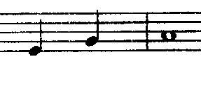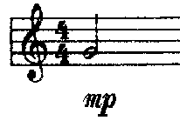

The Word became flesh and dwelt among us;

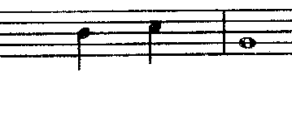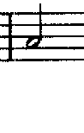

and we have seen his glory.

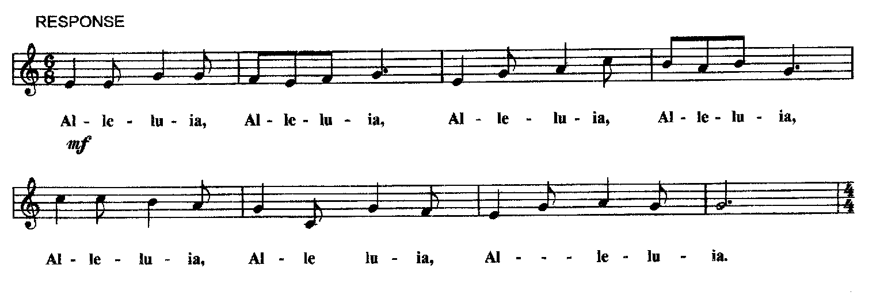

*(sing)* Hear the gospel of our Lord Jesus Christ according to St John:

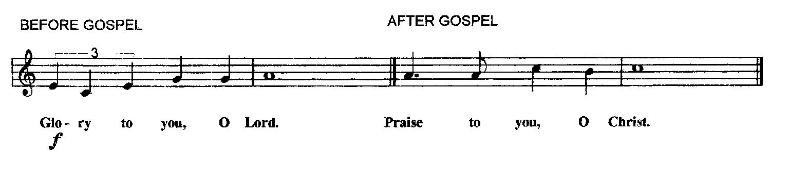

 This is the gospel of the Lord

**Midnight Mass of the Nativity**

**2018**

**THE GATHERING**

Entrance Hymn: 62 "O come all ye faithful" verses 1, 2 and 3

**THE BLESSING OF THE CRIB**

Priest: In the name of the Father and of the Son and of the Holy Spirit.

All: Amen.

Priest: Grace, mercy and peace from God our Father and the Lord Jesus Christ be with you

All: and also with you.

Priest: Dear friends, as we meet to celebrate the birth of Christ, let us pray that God will bless this crib, that all who worship his Son, born of the Virgin Mary, may come to share his life in glory:

God our Father, on this night your Son Jesus Christ was born of the Virgin Mary for us and for our salvation: ✠ bless this crib which we have prepared to celebrate that holy birth; may all who see it be strengthened in faith, and receive the fullness of life he came to bring; who is alive and reigns for ever.

All: Amen

Hymn: 62 "O come all ye faithful" verses 6 and 7